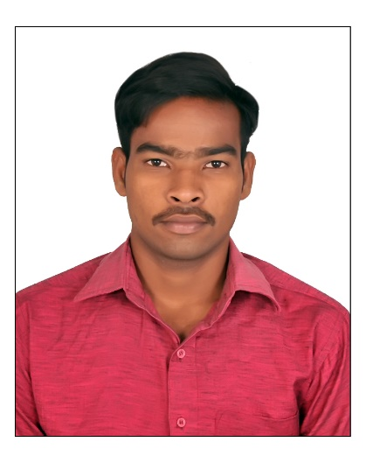

**H0BBIES**

Learning

Listening Music

Body workouts

[**k.naveen252@gmail.com**](mailto:k.naveen252@gmail.com)

+91 9949058991,

+91 8247494347

2-146, opt Andhra Bank,

Meeseva road, Ibrahimpatnam,

Krishna distric, AP-521456.

* HTML5, CSS3, JAVASCRIPT.
* JAVA,
* JAVA SWING,
* SERVLET
* SQL

**SOFTWARES KNOWN**

**CONTACT**

Seeking a fulltime position in a company that offers challenging job Opportunity. Where I can improve my skills and which provides me an environment to share knowledge with others for the success of the organization

**OBJECTIVE**

* Time Management
* Project Management skills
* Strategic thinking &
* Planning abilities
* Teamwork
* Leadership
* Problem solving
* Analytical skills
* Adaptability to change
* Communicational skills

**KEY SKILLS**

**EXPERIENCE**

Having 1+ year experience from 5th August 2018 to 26th September 2019 as a Supervisor and Incharge in MYNALA POWER SYSTEMS PRIVATE LIMITED at site location NTTPS Vijayawada.

**EDUCATION**

* **Andhra Loyola Institute of Engineering and Technology,**

**Vijayawada.**

Bachelor of Technology in Electrical and Electronic Engineering (B.TECH in EEE )

Aggregate : 61.63 %

Year of pass : 2018

* **Govt. Polytechnic college Vijayawada.**

Diploma in ELECTRICAL and ELECTRONICS ENGINEERING

Aggregate : 80 %

Year of pass : 2015

* **Brilliants Convent and High School**

SSC with a

GPA : 8.5

Year of pass : 2012

KURMAPU NAVEEN KUMAR

CURICULUM VITAE